**DAV PUBLIC SCHOOLS, ODISHA ZONE**

**QUESTION BANK**

**SUB : MATH CLASS-VI (2023-24)**

**TEXT BOOKS : NCERT MATH STD-VI**

**NCERT EXAMPLAR CLASS VI MATH**

**EXAM SCHEDULE 2023-24**

|  |  |  |
| --- | --- | --- |
| **NAME OF THE EXAM** | **DATE** | **FULL MARKS** |
| PERIODIC ASSESSMENT-I | 24 July 2023 to 31 July 2023 | 40 |

**Syllabus**

|  |  |  |
| --- | --- | --- |
| **CHAPTER** | **Periodic Assessment- I** | **Marks (40 Marks)** |
| **CHAPTER 1** | **Natural numbers &Whole numbers** | **12** |
| **CHAPTER 3** | **Integers** | **13** |
| **CHAPTER 8** | **Basic Geometrical concepts** | **9** |
| **CHAPTER 9** | **Line Segments** | **6** |

**TYPOLOGY OF QUESTIONS**

|  |  |  |
| --- | --- | --- |
| **1** | **MCQ** | **1 MARK** |
| **2** | **SHORT ANSWER TYPE QUESTION-I** | **2 MARKS** |
| **3** | **SHORT ANSWER TYPE QUESTION-II** | **3 MARKS** |
| **4** | **LONG ANSWER TYPE QUESTION** | **4MARKS** |

**NATURAL NUMBERS AND WHOLE NUMBERS**

**MCQ QUESTIONS (1 × 5 = 5)**

1. Which of the following will not represent zero?  
 a. 1 + 0 b. 0 × 0 c. 0/15 d. (110-110)/2

2. Which equation shows the distributive property of multiplication?

a) 112 × (23+ 17) = 112× 23 + 112 × 17

b) 542 + (99 × 1) = (542 + 99) × (542 + 1)

c) 100 - (10 × 2) = (100 – 10) × (100 – 2) d) a ÷ (b x c) = a ÷ b x a ÷c

3. The number of days in February 2024 is

a. XXXI b. XXX c. XXIX d. XXVIII

4.The least number should be added to 1104 so that it will be divisible by 17 is ________

a. 0 b.1 c.16 d. none of these

5. There are ---- places in millions period.

a.1 b.2 c.3. d.1000000

**FILL IN THE BLANKS (1 × 5 = 5)**

6.Millions place of international place value chart is same as ----- place of Indian place value

chart .

7. Total number of 5-digit numbers are -------

8. 87×120 - 87 × --- + 87 = 87× 100

9. If ______ is added to a number, the sum will remain the same. Hence ______is called the __________ in the whole numbers.

10. The least Natural Number is ------- more than the least whole number.

**VERY SHORT ANSWER (1 × 5 = 5)**

11.Write the roman numeral for 1234.

12.Write 40056789 in word in international place value system.

13.Write the greatest whole number which when rounded to nearest thousand becomes 7000.

14. How many whole numbers are there between 320 and 530?

15. Write the smallest 8-digit number that can be formed by 3 different digits.

**SHORT ANSWER-1 (2 × 5 = 5)**

16. How many metres should be added to 700m to make it 12km 50m?

17.a) Estimate 2457 + 678 by rounding off each number to nearest hundreds:

b) Estimate 857 × 6484 using the general rule.

18. Find the greatest 5-digit number divisible by 45.

19. Find the product by suitable rearrangement: 8×4768×125

20.Find the product of 564 **×** 998 using distributive properties.

**SHORT ANSWER-2 (3 × 5 = 15)**

21. Determine the sum of the three numbers as given below:

a) successor of MCLVIII

b) predecessor of greatest 4digit number

c) predecessor of the predecessor of 500

22.Find two nearest numbers of 56743 divisible by 32.

23.Arrange the given Roman numerals in ascending order.

LVII, XXII, XIV, CXVI, CCIX

24. **A bottle factory produces 985 bottles a day. How many bottles will the factory**

**produce in the month of April and May?**

**25. Which is greater? 130 x 24 – 18 or 130 x (24 -18)**

**LONG ANSWER (4 × 5 = 20)**

26. Simplify: 22 – [91– {60 – (10 –)}]

27. A school principal places orders for 95 chairs and 95 tables with a dealer. Each

chair costs ₹873 and each table costs ₹127. If the principal has given ₹25000 to

the dealer as an advance money, then what amount to be given to the dealer

now? (Use property)

28. **Solve using distributive property : 579×77 + 579×22 + 579**

**29.**A person had Rs150000 with him. He purchased a colour T.V. for Rs 18500, a

motor cycle for Rs 65880 and washing machine for Rs 37000. The rest of the

money he divided among 45 people. How much money each of them get ?

30. An engine pumps at 608 litre of water is 16sec. How many hours will it take to

pump out 684000 litres of water?

**INTEGERS**

**MCQ QUESTIONS (1 X 5 = 5)**

1. Which of the following statement is not true?
2. Integers are closed under addition.
3. Integers become progressively large as we move away from zero.
4. Absolute value of −5 is 5.
5. Product of two negative integers is always positive.

2. Which of the following statement is not true with respect to the given number line?

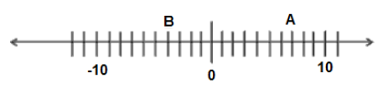

1. B is greater than −10 (b) A is greater than 0

(c) B is greater than A (d) B is smaller than 0

3. Arrange in descending order: −5, 8, −2, 4, 0

(a) −5, −2, 4, 0, 8 (b) 8, 4, 0, −2, −5

(c) −2, −5, 0, 8, 4 (d) −5, −2, 0, 4, 8

4. Sign of product of 357 negative integers and 82 positive integers is

1. Positive (b) Negative (c) 0 (d) Can’t be determined

5. If −8 ×▲ = 256 and −581 + ♣ = −549, then the value of ▲ ÷ ♣

1. −1 (b) 1 (c) −5 (d) 5

**FILL IN THE BLANKS (1 MARK)**

1. The additive inverse of the sum of −251 and 143 is ___________

2. −361 × (28 – 39) = −361 × 28 – 39 × _______

3. (−49) + 48 + (−49) + 48 + (−49) + 48 + ……. 50 terms equal to ________

4. Compare using <,> or =.

[ + 15] [−(−25) + (−40)]

5. 31 + {(−23) + 12} = {31 + (−23)} + 12 is an example of ____________ property.

**VERY SHORT ANSWER QUESTONS (1 MARK)**

1. A shopkeeper made a profit of Rs. 350 on Monday, incurred a loss of Rs 165 on

Tuesday and a loss of Rs 230 on Wednesday. What was his net profit or loss in

these 3 days?

1. Find the value of 324 × (−16) × 21 × 0 × (−4).
2. What number should be added to 45 to get the additive identity?

4. If A = 5 and B = 8 then find the value of $\left|-A\right|$– $\left|-B\right|$?

5.Compute (−1)4 + (−1)5

**SHORT ANSWER – I QUESTIONS (2 MARKS)**

6. Find the sum of integers –72, 237, 84, 72, –184, –37.

7. Using suitable properties, evaluate: 684 × (–54) + (–684) × 46

8. Find a pair of integers whose product is −21 and whose difference is 10.

9. Can the sum of successor and predecessor of an integer be an odd integer? Justify

your answer with an example.

10. What is the sum of all integers from −100 to 100?

**SHORT ANSWER – II QUESTIONS (3 MARKS)**

11.Simplify: (−7) + (−6) ÷ 2 – {(−5) × (−4) – (3 – 5)}

12.Subtract the product of −305 and 120 from the sum of 153 and −302.

13. Using distributive property, find (−38) × (−102)

14. Subtract the cube of (−4) from the cube of 4.

15. What power of (a) −2 is 256?

(b) −3 is 81?

**LONG ANSWER TYPE QUESTONS (4 MARKS)**

16.In a quiz competition 3 marks are given for every correct answer and −2 marks are

given for every incorrect answer and no marks for not attempting any question.

1. Sachin scored 24 marks. If he got 14 correct answers, how many questions has he attempted incorrectly?
2. Nalini scores (−7) marks in this competition, though she has got 9 correct answers. How many questions she has attempted incorrectly?

17. Find the value of the following:

* 1. 225 × (−494) + 225 × (−5) – 225
  2. (−80) × (12 – 7 – 19 – 86)

18. Verify that (a ÷ b) ÷ c ≠ a ÷ (b ÷ c) for a = −625, b = 25 and c = −5.

19. A cement company earns a profit of Rs.22 per bag of white cement and a loss of

Rs. 16 per bag of grey cement sold.

1. If the company sells 3000 bags of white cement and 5000 bags of grey cement in a month, what is its profit or loss?
2. What is the number of white cement bags it must sell to have neither profit nor loss, if the number of grey cement bags sold is 6600?

20. (a) Find the value of (−3)4 × 52 × (−10)3

(b)Verify: 132 – 52 = 122

**BASIC GEOMETRICAL CONCEPTS**

**MULTIPLE CHOICE QUESTIONS[1]**

1. Number of rays that can be drawn from a given point is

(a) 1 (b) 2 (c) 3 (d) many

2. Concurrent lines pass through

(a) different points (b) two points only

(c) more than one points (d) the same point

3. Two lines perpendicular to the same line are

(a) parallel (b) intersecting (c) concurrent (d) None

4. Number of lines passing through five collinear points is :

1. 1 (b) 2 (c) 3 (d) 5

5. When you define a point, you say that it

(a) has no dimension, but has a position (b) has length but no width

(c) has width but no length (d) has length and position

**FILL IN THE BLANKS:[1 $×5$]**

1. A plane contains __________ number of lines.
2. Number of line(s) can be pass through two distinct points is _______.
3. The meeting points where more than two lines intersect is called _____.
4. To name a line segment, we need at least ________ points.
5. On a number line, one end is at -5 and other at 9. The length of the line segment is _______.

**VERY SHORT ANSWER[1 $×5$]**

1. Divide the moon given alongside in to six parts by drawing just two

straight lines.

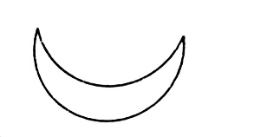

1. How many line segments can you cut off from a ray?
2. Give any two examples, from your environment, of a portion of a plane.
3. Draw any two closed figures, each made of line segments only.
4. Two planes are either parallel or they intersect each other in a point’. Is this statement true? Give reasons.

**SHORTANSWER-I [2 $×3$]**

1. Mark three non-collinear points A, B, C in your notebook. Draw lines through these points taking two at a time and name these lines. How many different lines can be drawn?
2. Arrange 24 balls in six rows with each row comprising 5.
3. 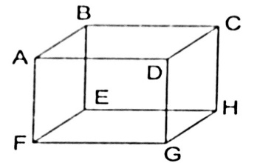 In the above figure, name:

(i)Plane parallel to ABCD.

(ii)Line of intersection of the planes EFGH and BCHE.

**SHORTANSWER-II** **[3 $×2$]**



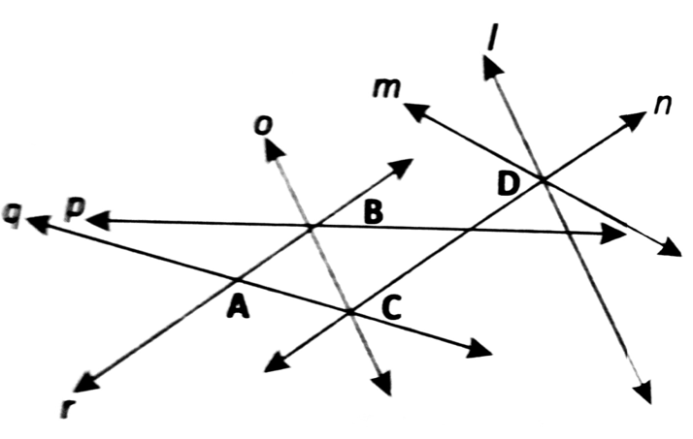

1. Name any two pairs of intersecting lines in the given figure.
2. Which lines are parallel to each other?
3. Name three sets of concurrent lines.
4. 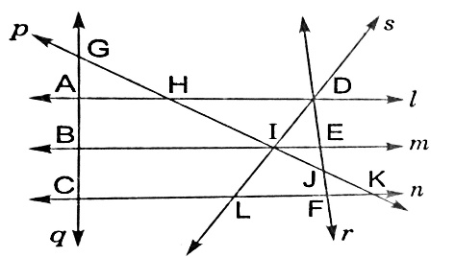

In the given figure, find

1. Four opposite rays formed at I.
2. Lines whose point of intersection is A.
3. Two sets of collinear points.

**LINE SEGMENTS**

**MULTIPLE CHOICE QUESTIONS**

1. The maximum number of line segment/s that can be drawn using four random non-collinear points given on a plan is/ are

a) 1 b) 4 c) 6 d) 8

1. A line segment is a part of

a) Ray b) Line c) Circle d) Both a & b

1. Teacher told the students to construct a rectangle using threads of different lengths, ie. 4cm for length and 3cm for breadth. What would be the total length of threads used?

a) 14 cm b) 12cm c) 10cm d) 7cm

**FILL IN THE BLANKS(1 × 3)**

1. ________ is a closed figure that can be drawn using the least number of line segments.
2. Comparison of two or more than two line segments can be done by using the geometrical instrument, called _______.
3. 1 metre = _______ millimetre

**VERY SHORT ANSWER (1 × 3)**

* 1. Count the possible number of line segments in the given figure. 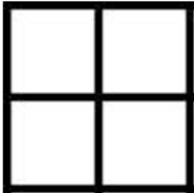
  2. If the difference of lengths of two lines segments is 5cm and one of them is 3 cm, find the length of the other.
  3. Two vertical poles of equal lengths are placed one upon the other and the combined length is 60 cm. Find the length of each pole.

**SHORT ANSWER (2 × 3)**

1**.** AB is a line segment of length 5 cm, P is a point on it. AP = 2cm, find the length of BP.

2.

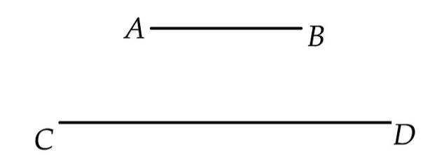Compare the lengths of two line segments using ruler and divider. Also find their difference.

3. Give two examples of line segments in real life situations**.**

**SHORT ANSWER TYPE II(3 × 3)**

1. Construct a line segment PQ where PR = 3cm, RQ= 7cm and all the points lie on a line.
2. Using compass and ruler draw an equilateral triangle of each side 5 cm
3. Draw a quadrilateral using ruler and divider whose sides are AB= CD= 5cm, BC = DA = 3cm**.**