DAV PUBLIC SCHOOL KHERA KHURD / BUDHPUR

School Website : davpskherakhurd.com , School Tel No. 01127844245 , 01127201930

SUMMER BREAK HOLIDAYS HOMEWORK

**Class-VI**

**English**

**NOTE: DO HOLIDAY HOME WORK IN PROPER FORMAT**

**WRITING SHOULD BE VERY NEAT AND CLEAN**

HOLIDAY HOMEWORK WILL BE ASSESSED FOR 5 MARKS Each subject

ACTIVITY ; SHOW AND TELL ACTIVITY (2.5 marks )

Paste the picture of one thing related to your favourite hobby and write few lines about it.

VIVA 2.5 marks

PROJECT ; Prepare a book cover of the story book with its author name and a beautiful picture

GROUP 1 Ruskin bond story GR OUP 2 Enid Bliton Story

GROUP 3 H.G Wells story GROUP 4 R.K NARAYAN

**READING TASK :** Read unit ‘ Hobbies’ of your reader book and do all the exercises in the book.

NOTEBOOK CHECKING 5 MARKS

**Hindi**

कक्षा ६ प्रत्येक ग्रुप कविता के दिए गए रस के अनुसार कविता याद कीजिए व फाइल में लिखकर उसका भावार्थ स्पष्ट कीजिए

ग्रुप  १ वीर रस ग्रुप , २ हास्य रस ,ग्रुप ३   वात्सल्य रस , ग्रुप ४ करुणा रस

परियोजना कार्य

ग्रुप १

एवरेस्ट के शिखर पर पहुँचने वाले पर्वतरोहियों की जानकारी एकत्र कीजिए व सचित्र फाइल में लगाइए।

ग्रूप २

बर्फीले क्षेत्रों में रहने वालों का जीवन कठिनायों से भरा होता है।  विश्व के अलग अलग ठन्डे देशों में रहने वाले लोगों के जीवन के विषय में अधिकतम जानकारी एकत्र कीजिए और परियोजना तैयार कीजिए।

ग्रुप ३

अधिक वर्षा के कारण देश के किन किन क्षेत्रों में बाढ़ आ जाती है उसकी सूची तैयार कीजिए और यह भी बताइए की  यदि आप बाढ़ में घिर गए हैं या देखते देखते दूसरे लोग भी बाढ़ में घिर गए है आप स्वयं को और दूसरों को कैसे बचाएँगे।

ग्रुप ४

पानी की बचत और पानी को प्रदूषित होने से बचाने वाली सन्देश   
फीतियाँ  बनाइए और देश में पीने के पानी की समस्या को समाधान सुझाते  हुए विचार लिखिए

**Maths**

1) Activity:

From the newspaper and magazines collect the examples related to the following

terms and make a collage of these cuttings in the activity file :

1) Parallel lines ( group 1 )

2) Intersecting lines ( group 2 )

3) Angles ( group 3 )

4) Area ( group 4 )

2) Project

Make a project on the following topics

1) Prime Numbers. ( group 1 )

2) Composite Numbers. ( group 2 )

3) Even Numbers. ( group 3)

4) Odd Numbers. ( group 4 )

3) Do daily ten questions from the following chapters in a separate register :

1) Natural Numbers and Whole numbers (Brain teaser)

2) Factors and multiples (Brain teaser)

**G.Science**

1. **SEA (SUBJECT ENRICHMENT ACTIVITY): -2.5 MARKS**

|  |  |
| --- | --- |
| Group | Activity |
| A | To measure the length of a curved line (indirect method) |
| B | Make a collage of vertebrate pictures &also write any 2 features of vertebrates . |
| C | Make a collage of invertebrate pictures &also write any 2 features of invertebrates. |
| D | Make a collage titled "A moment of movement"(pictures of types of motion) |

**Project : (2.5 MARKS)**

|  |  |
| --- | --- |
| Group | Project |
| A | To make a model of an Amoeba |
| B | To make a model to show arrangement of particles in the three states of matter. |
| C | Make Flash Cards of Vitamin A,B &C ( sources, functions, deficiency diseases &symptoms |
| D | Make Flash Cards of Vitamin D,E &K ( sources ,functions ,deficiency diseases &symptoms |

**Social Science**

Q1- Make a project on a particular religion assigned to the group, the report should carry the following information :

A. Founder of the religion

B. Symbol

C. Main teaching

D. Their popular in India.

Group A - Hinduism

Group B - Islam

Group C - Christianity

Group D - Sikhism.

Q2 - Project-

Indus valley civilization is the first planned civilization in Indian subcontinent. It was famous for its town planning. Make a picture album showing different features of it. Use your creative idea to prepare picture album. It should include -

A. Great Bath

B. Citadel

C. Granaries

D. Drainage system

**Sanskrit**



GR 4

GR 1

GR 2

GR 3

**Computer**

Make a chart on any one of the following

1. Application software and system software
2. Virus and antivirus

Take light green pastel sheet and use the sheet in landscape .The border of the sheet should be black .

**General knowledge**

Class 6 G K holidays homework

Read newspaper daily and make a collage of the important events which took place during summer vacation.

**Music**

Learn the following

1. Sargam 3,4,5,6,
2. DAV Anthem
3. Mantras

**Art:**

Make a pen stand with Fibre Sheet and decorate it with Glitter Tube and glass colour as shown in the picture.

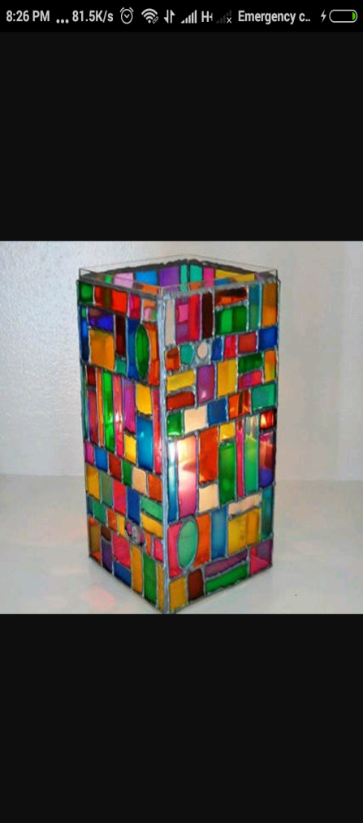

**Vedpath**

1. द्रोणाचार्य के जीवन पर आधारित एक सारगर्भित लेख लिखें।
2. आचमन मंत्र स्मरण कीजिए।
3. प्रातः शाम १० मिनट मैडिटेशन कीजिए।