DAV MUKHYAMANTRI PUBLIC SCHOOL, VISHRAMPURI DIST: KONDAGAON (CG)
Brief history of your school: Dav Mukhya mantri public school Vishrampuri is located at rural area in the block- Baderajpur Dist.Kondagaon.The School is in fact in the woods. Supers imposed two storied building houses 20 teachers and 547 Children. The school offers B P C /M P C and commerce subject’s up to Senior Secondary level under CBSE syllabus. It caters to the educational needs of tribal children who are primarily first-generation learners.
Over a period of 06 years DAVMMPS Vishrampuri has succeeded in enhancing the roll strength, regularity of pupils, garnered in establishing rappo with parents, improving results of students especially for classes X and XII drawing best wishes of local authorities and above all clinching prizes in co-curricular activities at block and district level.
It is my pleasure to apprise at this juncture that the school possesses well trained and experienced teaching staff, who are dedicated and determined. They ensure to bring out the latent talents of the children and channelize it in desired direction. They undergo training conducted by CBSE and Dav Nodal Centre Raipur from time to time. Thus, they update their skills and capacities.
Apart from regular teaching-learning process, the school imparts training on 21st century skills, soft skills to the students.
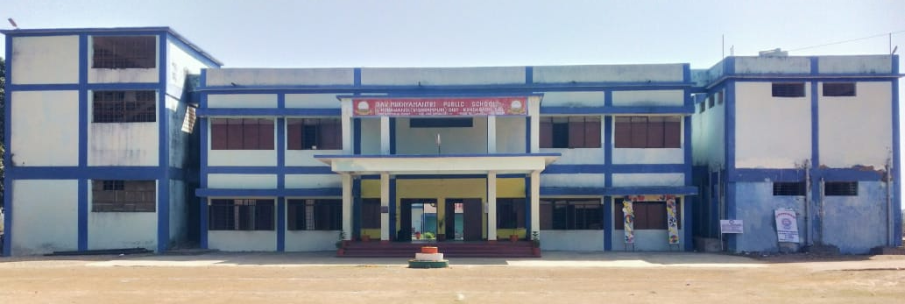
At present the school is striving to secure accreditation from Nabet-Qci a distinguished milestone and a rare privilege extended to few schools. 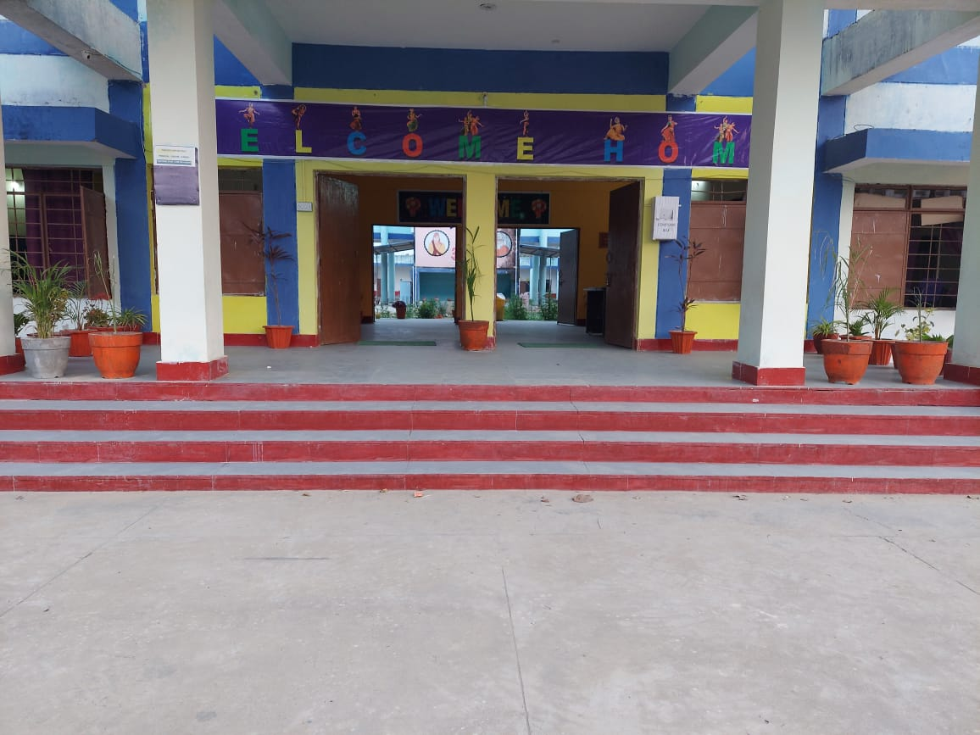
Thus, in a nutshell, DAVMMPS Vishrampuri has carved a niche in the district. KONDAGAON and surely will achieve many more benchmarks in the days to come. Certainly, the students will leave their footprints over the sands of time.

- School Address : DAV mukhyamntri public school
Vishrampuri, vill.– Honawandi
Pin code - 494347
- Year of Establishment : 2016
- CBSE Affiliation No. : 3330237
- School Code : 17015
- DAV PS Code : CG-066
- School Contact No. : 7587017419
- School Email Id : davmmpsvishrampuri@gmail.com
- School Website Add. : www.davmpsvishrampuri.in
- Chairman – LMC : NAME R. K. Leekha
Contact : 9416042829
Email ID : leekhark@yahoo.com
- Head (Principal/HM/In-charge): B. Padmavathi Rao NAME Principal (Designation)
Contact No. : 9406226228
Email Id : Pammi7676@gmail.com
Year | RTE | Govt. | Existing | DAV (Payment) | Total
2019 – 20 | 253 | 50 | 82 | 66 | 451
2020 – 21 | 276 | 57 | 65 | 78 | 476
2021 – 22 | 295 | 75 | 36 | 78 | 484
2022 - 23 | 322 | 83 | 0 | 142 | 547
- Total Student Strength: 547 (Boys: 282 & Girls: 265)
- Total No. of Board class Students: X 28 and XII 33 (2022 – 23)
- Academic Status: Pass Percentage in class X & XII (Last 5 years)
Year | 2017-18 | 2018 – 19 | 2019 – 20 | 2020 – 21 | 2021 - 22
X | 97% | 97% | 94% | 100% | 100%
XII | 59% | 23% | 39% | 100% | 93.54%

- Board Students (90% & above Scorer) Name & Yr: ………………………………..
- Staff Status: Total post as per approved budget : 21
Total Staff as on date (01/01/2023) : 20
(Regular: 03 Adhoc: 00 89 Basis: 17 )
- Academic Achievements: (National/ State level) selection in Medical/Engineering etc. with the
name of college and year.
- Sports/Other Achievements: (National/ State level) selection/winner (If any) State Level- Ramprasad 3rd Posistion (1500 meeter rase).

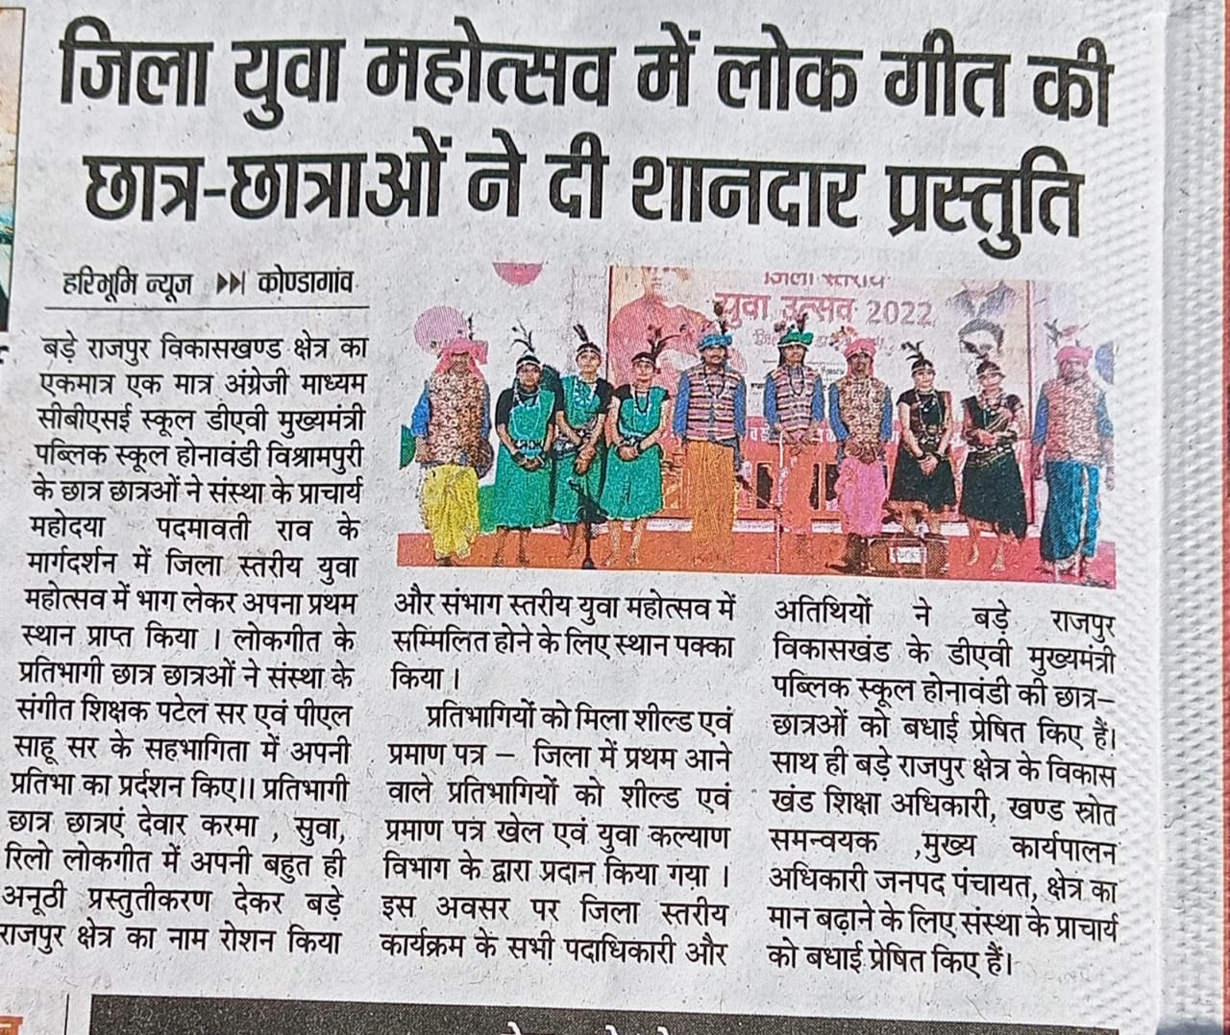
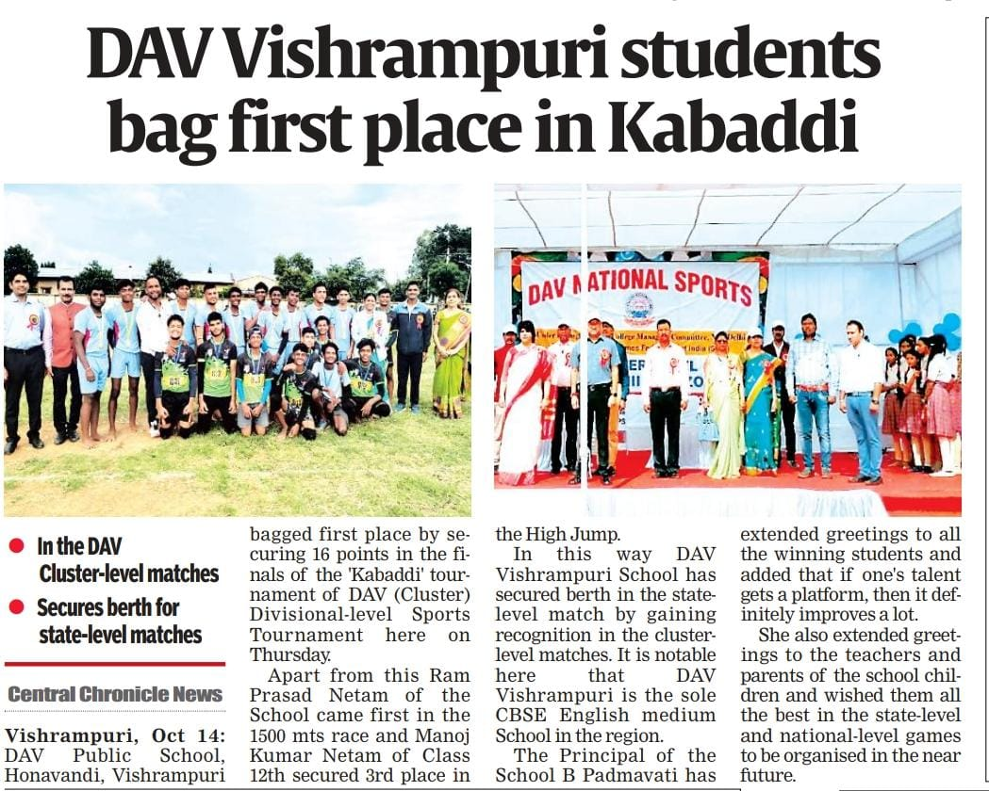
- Best Pics. (Only three best Pics); School Building (front), School Infra. (best), School Activity.

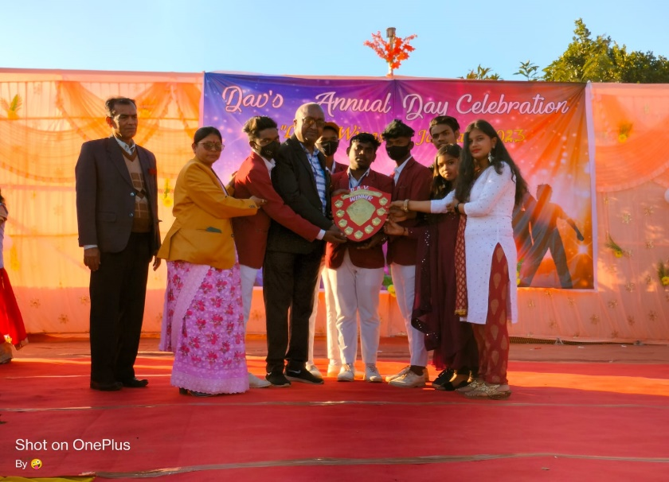
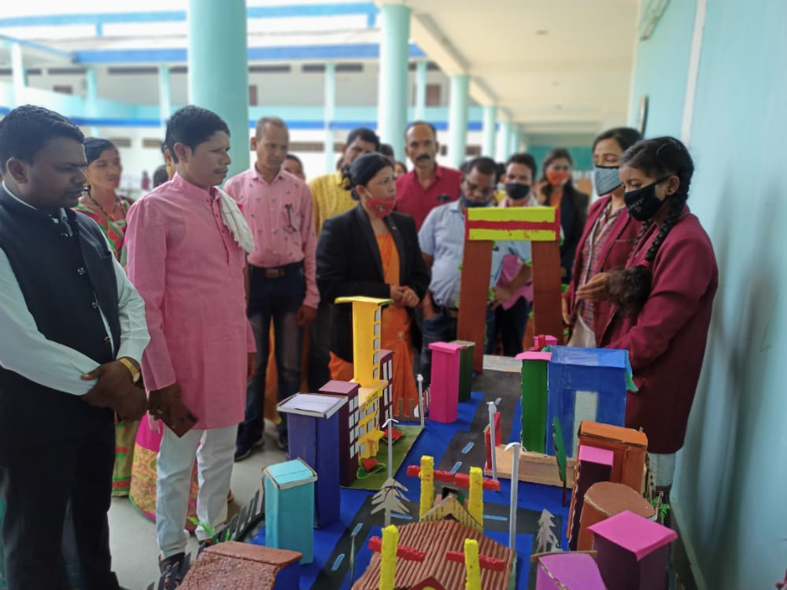

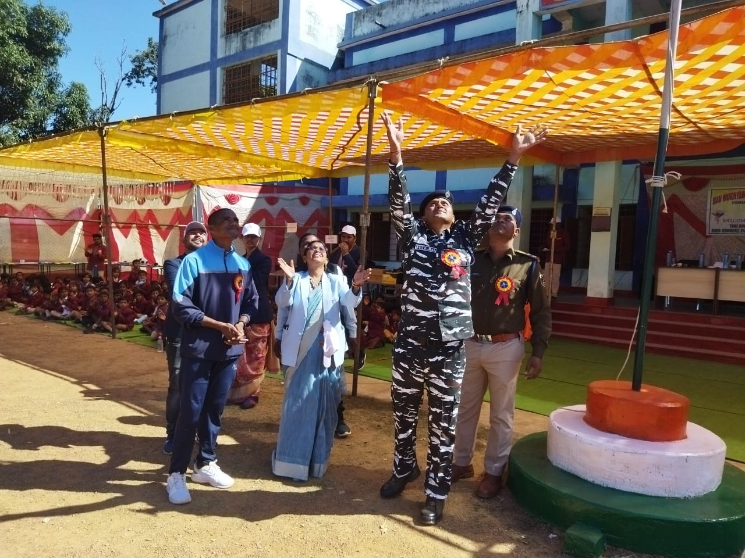
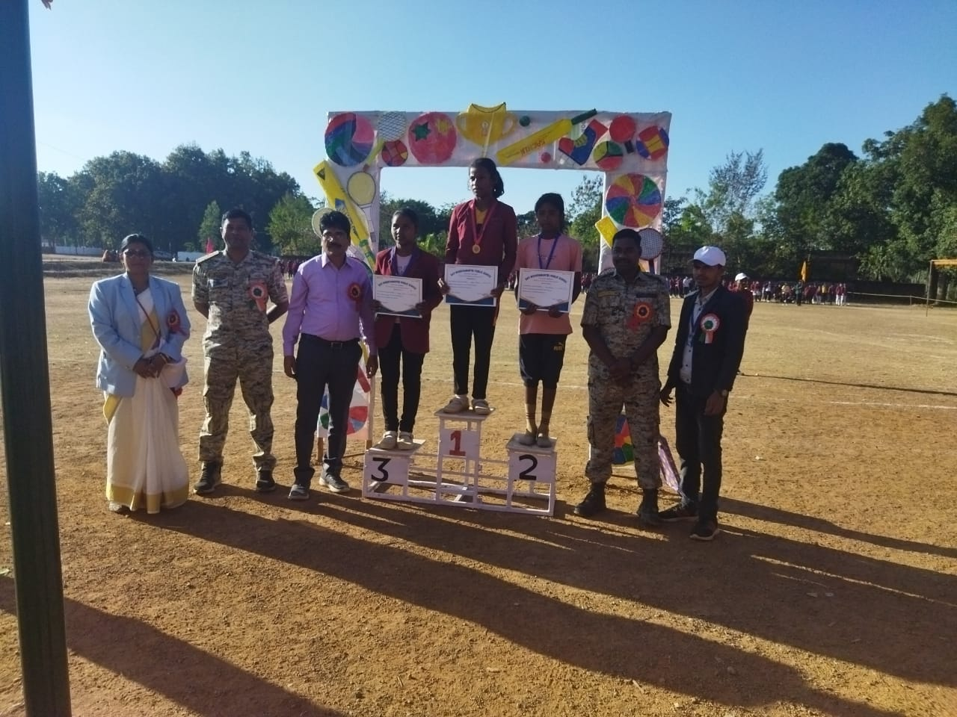

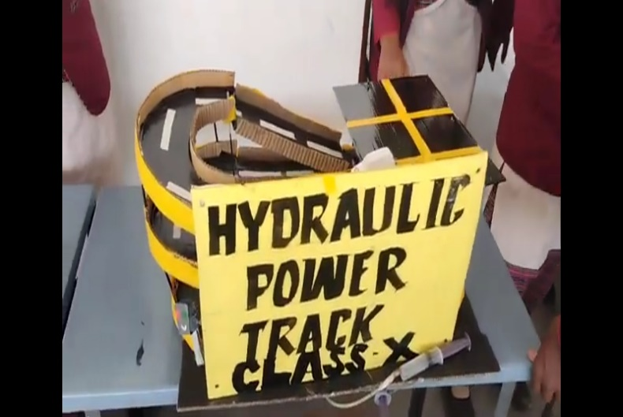
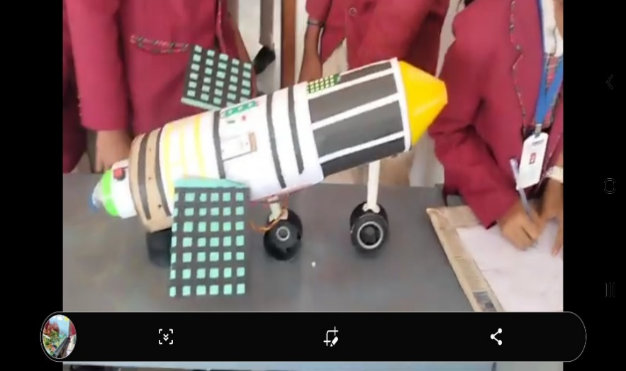

- Any other Highlights: …………………………………………………………..

Note: Please provide the data & info. in limited words, so that the same can be arranged in Max 2 page (pl ref. sample page)

